Before the commit any file on our computer is placed in so-called Working Directory

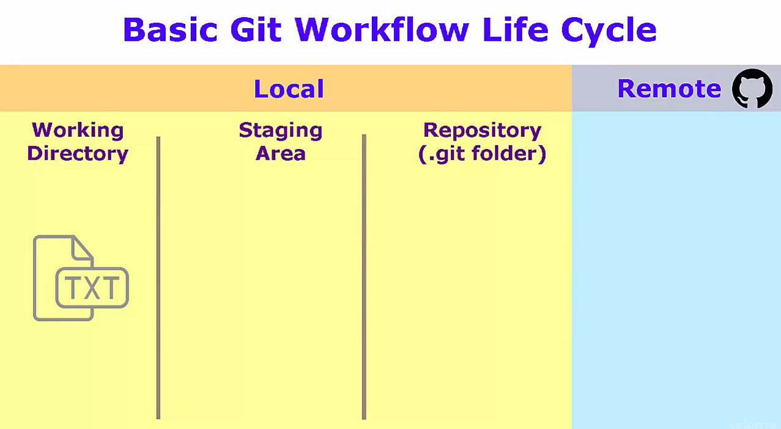

This can be seen when entering **git status** command, which tells us, that there is an file, but is not yet „tracked“ by Git

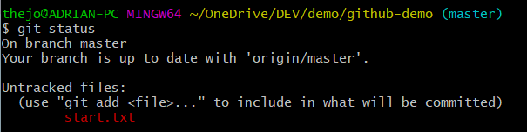

This changes once we add the file tot he local staging area – **git add ‚file name‘**

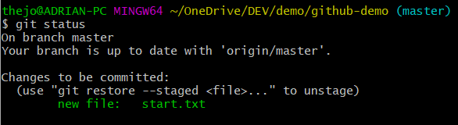

Graphically this can be described as follows

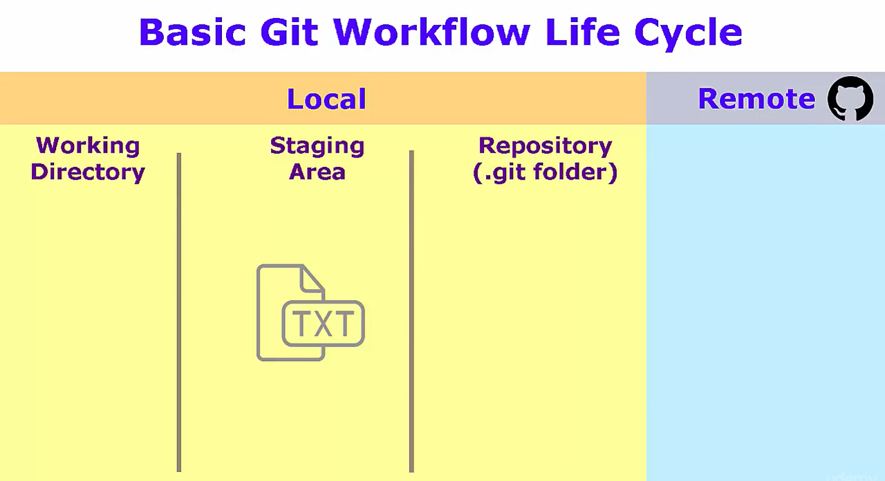

Once we put in **git commit -m ‘short description’** Git places our file to the Local Repository and clears the Staging Area

REMEMBER: Commit is still a local command!

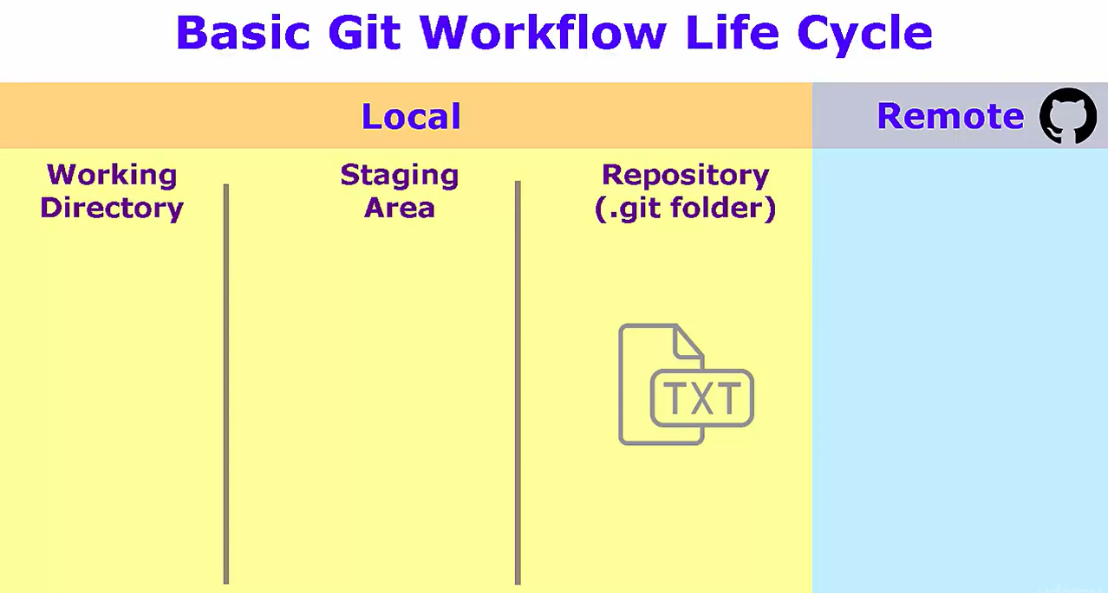

**Git push origin master**

***origin*** – refers to the GitHub copy of our repository

***master*** – refers tot he default and only branch in the repository

If all goes well, then the final result should look as follows

